**A** message from Carlo des Dorides, GSA Executive Director

***Published:***

*20 December 2019*

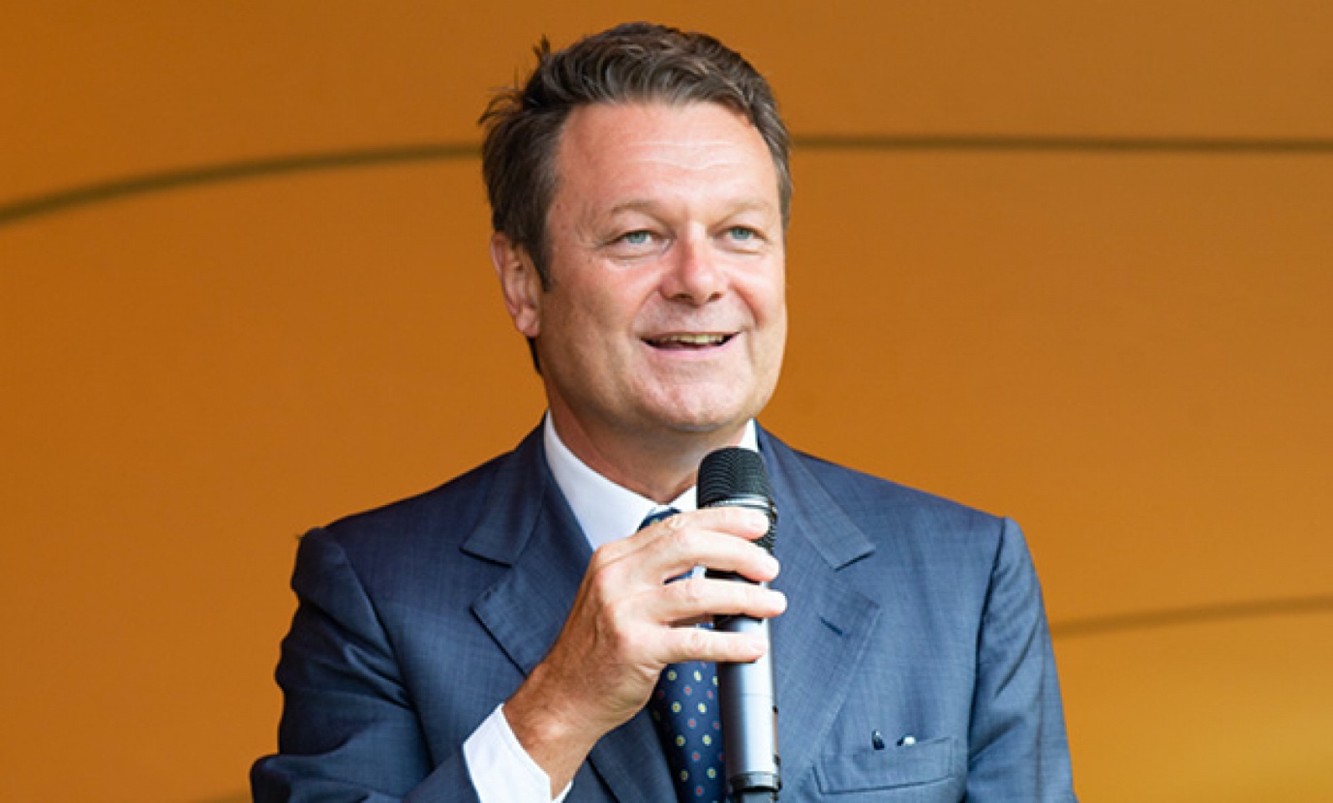

*Carlo des Dorides, GSA Executive Director*

**This has been a year of tremendous growth for the GSA, Galileo, EGNOS and the European Space Programme as a whole. We hit the ground running in 2019, buoyed by a wave of optimism following the successful European Space Week, held in in Marseille last December.**

At the end of 2018 we launched the Accuracy Matters campaign to raise awareness among end users and the public about the benefits of Galileo. This campaign continued to run throughout 2019 and has been very effective in raising the public profile of the European space programme in general and of Galileo in particular.

Throughout the year, we stayed true to our mission of putting users at the centre of Galileo service provision and work continued at full speed to prepare for the launch of Full Operational Capability next year. In February, we commissioned a batch of four Galileo satellites, bringing the number of launched satellites to 26. February also saw the launch of the world’s first Galileo-enabled personal location beacon (PLB), with the Return Link Service endorsed by COSPAS-SARSAT towards the end of the year, further consolidating Galileo’s contribution to global search and rescue.

In aviation, the European space programme continued to make a significant contribution to increased safety and efficiency, and the GSA signed a Memorandum of Understanding with the deployment manager for the Single European Sky ATM Research (SESAR) on future cooperation to modernise EU air traffic management by leveraging Galileo and EGNOS.

EGNOS is continuing its evolution towards EGNOS V3, which will augment both GPS and Galileo in the L1 and L5 bands, supported by payload launched this year. Furthermore, following the successful testing of EGNOS corrections in the maritime domain at the end of last year, EGNOS has also been performing well for the maritime community.

There were major developments for the space sector in Europe in April, when the European Parliament endorsed a provisional agreement on the EU Space Programme for 2021-2027. This new EUR 16-billion programme will help maintain and further enhance the EU's leadership in space. The new programme also has major implications for the GSA, which will grow into the European Agency for the Space Programme (EUSPA) with an expanded mandate to manage the market uptake and communications of the Copernicus Earth observation programme, helping ensure that synergies between Galileo and Copernicus can be exploited to the benefit of European society and business. The Space Programme also introduces the new security-related space initiatives Space and Situational Awareness (SSA) and Governmental Satellite Communication (GOVSATCOM), which will put Europe in a better position to react to ongoing changes in the international space sector.

The skies were not entirely cloud-free this year, however. In July a technical incident related to the Galileo ground infrastructure resulted in a temporary interruption of the Galileo initial navigation and timing services. Following the incident, we worked closely with all our partners to remedy the situation as quickly as possible and an Independent Inquiry Board was set up by the European Commission to identify the root causes of the incident. While this incident was a setback, valuable lessons were learned ahead of reaching Full Operational Capability and I believe that the GSA and the Galileo programme will be stronger as a result.

September was an exciting month. Galileo reached a major milestone, when the estimated number of Galileo-enabled smartphones in use reached 1 billion. At the same time, the GSA celebrated its 15th anniversary, as part of which we signed a cooperation agreement with the European Investment Bank to support investment in the European space-based service economy. This agreement will help ensure that the European space programme is leveraged to the fullest extent to allow Europeans reap the greatest possible benefits in terms of economic growth and job creation.

In October we launched the 6th issue of our GNSS Market Report. Providing comprehensive information on the dynamic global GNSS market along with in-depth analysis of the latest global trends and developments, this report was eagerly awaited by all market stakeholders and was downloaded over 1,000 times in the first 24 hours. The 1-billion smartphones milestone reached in the previous month, and the market uptake figures in the Market Report, particularly in new markets such as drones and New Space, are extremely encouraging and indicate a growing EU share of the market for downstream applications.

The year drew to a close with three successful demos stemming from GSA research and development projects (Horizon 2020 and Fundamental Elements), again clearly showing the tangible benefits and innovation delivered when EU funding, industry and SMEs come together. In the first of these the GSA and its partners successfully performed end-to-end tests on remote beacon activation using the Galileo Return Link Service (RLS), helping to validate the operational concept for a potential new use of Galileo to support fast response in distress situations. Then we had a live demo of the first autonomous vehicle powered by Galileo, during which an electric car was autonomously driven on a track and public roads, in a world first for Galileo. The PRoPART Galileo-based positioning solution for automated trucks and advanced driver assistance systems was also successfully tested at the end of the month.

These are exciting times for the space industry, 2020 will mark a turning point for Europe’s space programmes and for the GSA, with the Galileo programme getting closer to Full Operational Capability and the GSA to take up its expanded responsibilities within the European Agency for the Space Programme. In the 15 years since it was created, the GSA has put together a uniquely talented and interdisciplinary team with a diverse range of skills and expertise. As a result, the GSA has a stronger basis than ever and is ready to tackle the challenges ahead and turn Europe’s investment in space into opportunities for growth.

EUSPA will usher in a new era for the EU space programme. With its expanded mandate, our team will work to maintain our excellent performance in operations management, service delivery and security. We will also open up new markets and applications, create new funding opportunities and reach out to new stakeholders and user communities. Consolidation of the EU space programmes within one agency will make it possible to explore new horizons and create even stronger links between our satellites in space and the needs of users on the ground.

Our core aim will always be to strengthen the European space programme, while at the same time building an Agency that is future-proof, ready to learn and grow and quickly respond to change, because it is only in this way that we can consolidate the EU’s position as a global space power.

As the year draws to a close, I would like to express my sincere gratitude to all the GSA staff for their hard work and commitment throughout the year, and to the European GNSS user community for their continued trust and support. It is thanks to this support that European GNSS continues to flourish.

**Best wishes for 2020 to all of you!**